NAME:Rishik JK
REG.NO :192511052

CSA1702-ARTIFICIAL INTELLIGENCE
LAB EXPERIMENT

Experiment 8 – Depth First Search (DFS)

AIM
To write a Python program to implement Depth First Search (DFS) for traversing a graph.

ALGORITHM
- Start the program.
- Create a graph with nodes and their neighbours.
- Select the starting node.
- Visit the starting node.
- Visit an unvisited neighbour of the current node.
- Continue deeply until no unvisited node is available.
- Backtrack and visit the remaining nodes.
- Stop the program.
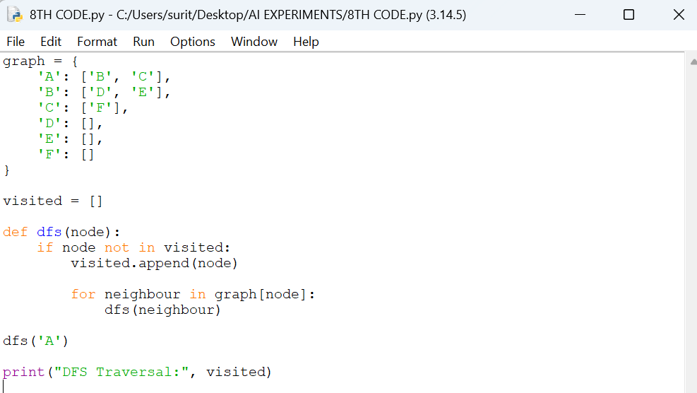

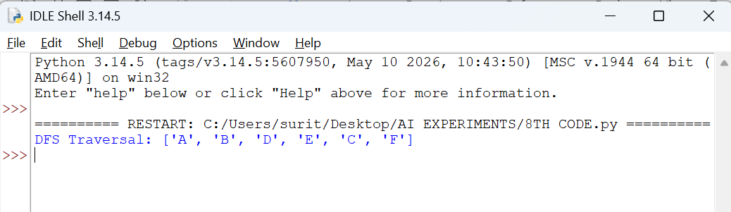

RESULT
Thus, the Depth First Search algorithm was implemented successfully using Python.

